Fundraising for the Rohingya

**Why did I fundraise for the Rohingya**

The idea of helping the Rohingya started back in June 2012 when I saw posts from my Pakistani friends about the Rohingya’s horrible situation. Out of curiosity I tried to find out who the Rohingya’s were and how bad their situation really was. I then learned that they have been regarded as one of the most persecuted minorities in the world by both UN and Amnesty.

Even though this has been the case for decades, their situation shows no signs of improvement. The Burmese do not see the Rohingya as one of them even though they have been living together in Burma for centuries. The Rohingya migrated from India and Bangladesh. They look a little different from the other Burmese and have different culture too.

The Rohingya community has experienced real terrorism committed against civilians in the form of murder, rape and arrests in mass by the Burmese security forces along with some extremists, brutally and flagrantly. To make matters worse, the Burmese government has also restricted humanitarian access to the Rohingya community which has left more than hundreds of thousands displaced without food, shelter and medical care, according to Amnesty International.  
  
As much as how the world community should have intervened into this inhumane genocide that has been happening in Burma for a long time, it didn’t happen. Therefore, I couldn’t help but started feeling very strongly that I had to do something and see how I could make a difference as a private individual.

**Action speaks louder**

Anyone who knows about the Rohingya’s situation questions the silence of the world community and especially the Medias. I therefore came up with the idea of having my own little fundraising on Facebook and see how much I could raise from my own network.

As it is illegal in Malaysia to use my personal account to collect money for aid work, I therefore used the accounts of Muslim Professional Forum (MPF) from Malaysia, and Danish Muslim Aid (DM-Aid) from Denmark. I also received help with the posters by some friends who have been very supportive, to name just a few, Karen and Najmia, and also several MPF members.

Once the poster was ready I sent it out to my friends by emails and also posted it on Facebook. My friends did the same and very quickly the poster was viewed by hundreds if not thousands in both Malaysia and Denmark.

In the end, we managed to collect approximately USD11.000 in Malaysia, and in Denmark the number exceeded USD15.000.

**The Rohingya in Bangladesh**

On 10th November 2012, I took off from Malaysia and arrived in Dhaka late in the evening.

As I unfortunately couldn’t transfer the money to my contact person in Bangladesh, I had to carry approximately USD17.000 with me. My dedicated driver mysteriously did not turn up as expected, I therefore had to settle for a hotel that was not too far from the airport, checked in and left my luggage there before I headed out for dinner.

After having a good dinner, I went back to the hotel and was all ready to jump into the bed after a long day – just to find out that the hotel personnel had somehow lost my room key. I can’t recall now how I managed to survive the 2 hours before the locksmith finally broke the lock and let me in, but I can totally remember the utmost excitement I felt when all the obstacles to my long missed bed were cleared ☺

The day after, I met with the director of Muslim Aid to get a better understanding about the situation of the Rohingya in Bangladesh. He unfortunately confirmed my worries about the difficulty of entering the Rohingya refugee camps. He also told me that finding Rohingya people and just give them aid openly was not possible due to the restrictions put by the government. The political situation in Bangladesh simply makes helping the refugees from Burma very difficult.

The same afternoon I took a flight to Chittagong where I had to meet with Mohamad, my contact person from an organisation called Rohingya Solidarity Organization for Rights (RSOR). He has been working closely with Abdul Wahid Petersen from DM-Aid for some time. He is a very pleasant and warm man who has been fighting for the rights of his people since he was very young. He is a Rohingya himself and his family escaped from Burma when he was still a little boy.

He checked me in to my hotel where we started planning how to bring aid to the Rohingya refugees. He told me that I could not enter the refugee camps since it was prohibited to help the illegal Rohingya refugees outside the authorised refugee camps. Mohamad told me that there are approximately 400.000 Rohingya refugees in Bangladesh where most of them are illegal in the country. He knew where to find the illegal refugees, so I did not have to enter the camps to be able to help. He also told me that the really needy ones were actually those outside the authorised refugee camps since the government were taking care of those in the camps.

We later came to an agreement to channel the donations to the following:

1. Students
2. Poor families
3. Teachers
4. Orphans
5. 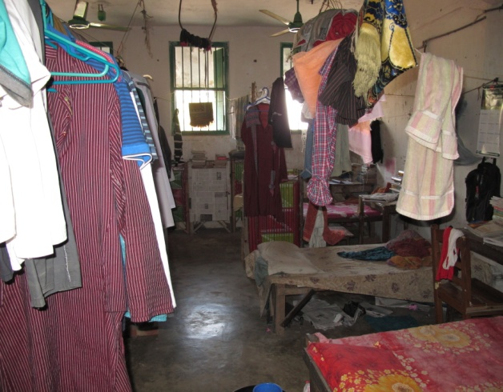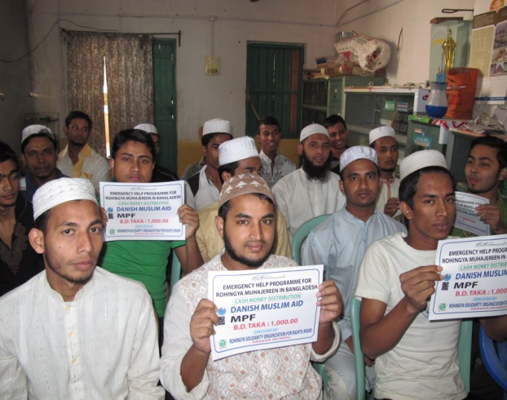Medical help

After a good night’s rest, Mohamad picked me up from the hotel and took me to a college where the poorest students were both studying and sleeping. A group of them were Rohingya refugees. We donated to the students so they could pay their tuition fees, buy some food, clothes and medicine.

We also donated food packages to the needy that consisted of 15kg of rice, 2kg of onion, 2kg of potatoes, cooking oil, dal, spices, salt, soap and medicine. This was done in a dark garage behind closed doors, where a big group of men and women were waiting to receive the packages. We had to do it in secrecy as again it was illegal to help the Rohingya openly. There had been cases where the police or military confiscated all the aid and send the ones bringing the aid out of the country. Since we didn’t want that to happen to us, we just had to behave like criminals.

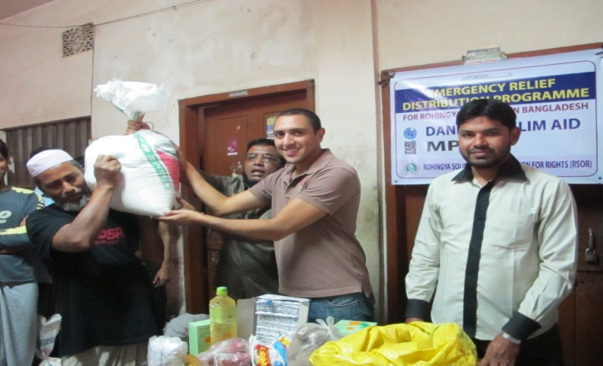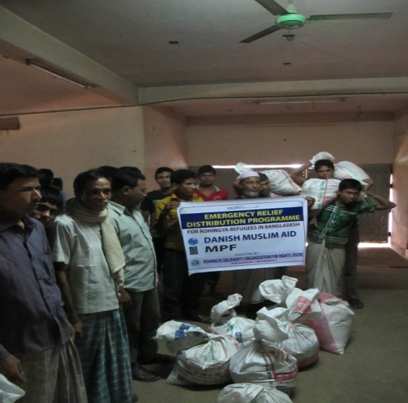

**The illegal Refugee camp**

The same evening I took a bus to Cox Bazar to meet with another contact person that I got in touch with after I arrived in Bangladesh. He claimed that he could get me into the Rohingya refugee camps. Even though I had been told by several sources that it was impossible to even get near to the camps, I was willing to take the chance.

Arriving in Cox Bazar very late in the evening, I checked in to the first hotel that was looking decent. The room was big and had two beds. I did not realise why I needed two beds in the room until the light was off and I realised I was sharing the room with a swarm of mosquitoes!

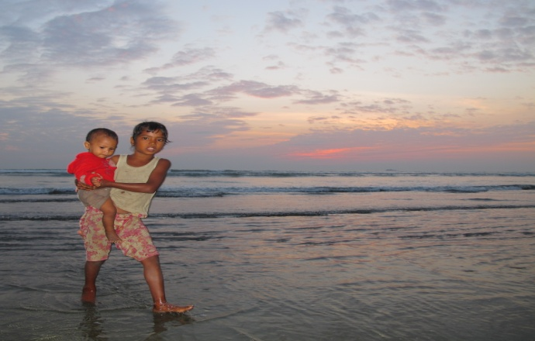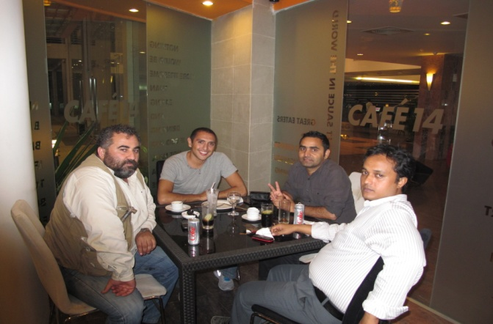The next day, I walked around in the area and relaxed at the beach which the locals claimed was the largest in the world. In the evening I met with my contact person who brought along 3 of his friends. There I was sitting with a Bengali Muslim, a Nepalese Hindu and a Georgian Orthodox Christian. We met to plan how I could enter the refugee camp and help refugees from Burma. I really thought it was a beautiful moment to experience individuals with different religion, culture, background and nationalities, united to help a group of people they had no relation to. We agreed that I should act as the director from London who was supposed to be checking the facilities of the illegal refugee camps before closing them down.

So the following morning I woke up like a boss, jumped into the van of my contact person and drove straight to the illegal Rohingya refugee camp. We passed several military check points on the way. They all just looked at me, nodded and let us pass. I was surely looking like a boss for a day!

When I finally arrived, I was totally shocked by what I saw. Those refugees were living in huts built in the simplest and crudest way. It was raining that day which made me realise that most of the huts were not waterproof. Their small homes – if you can call it a home at all – were literally dripping all over the place. They simply had nowhere to hide.

I walked around in the camp for more than 30 minutes. I saw hopeless eyes everywhere I went – youngsters, fathers, mothers, grandparents, they all had the same hopeless look.

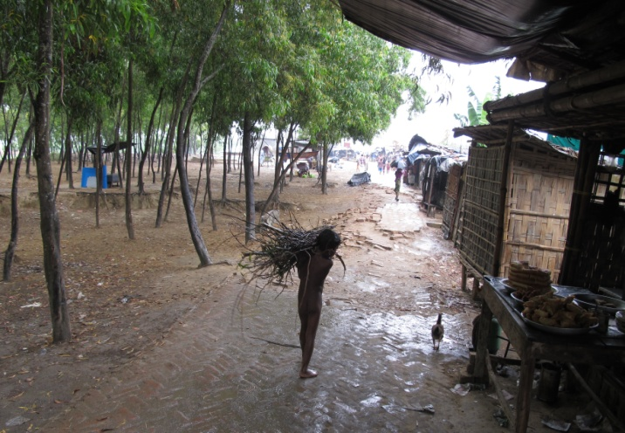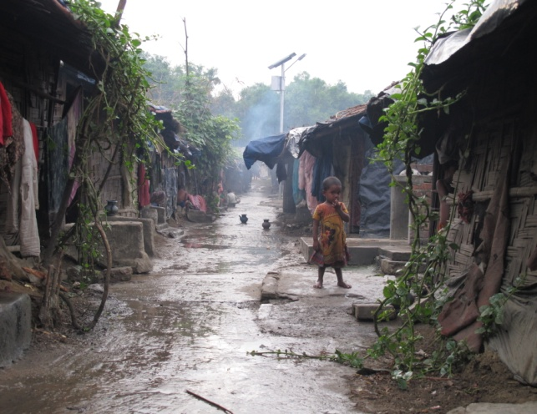The camp had 14.000 illegal refugees. The camp itself was illegal and the only reason it was still there is that the government does not know where to move the 14.000 refugees. They are not allowed to work and if they are caught working they will be put in jail. A woman in the camp followed me for some distance before she stopped and started begging me to help her husband who was caught working illegally as a bicycle taxi driver and now imprisoned. The poor woman and her children had not seen their husband and father for more than 2 years.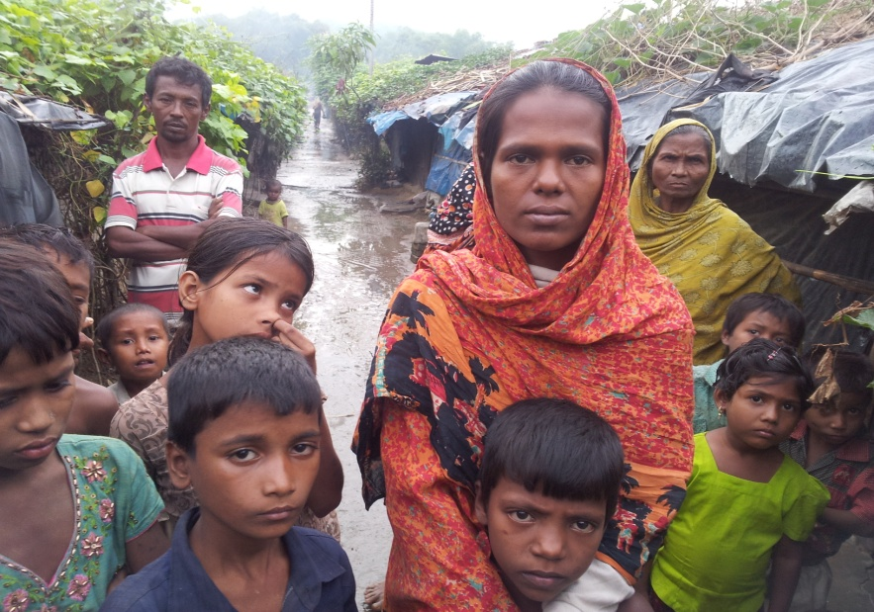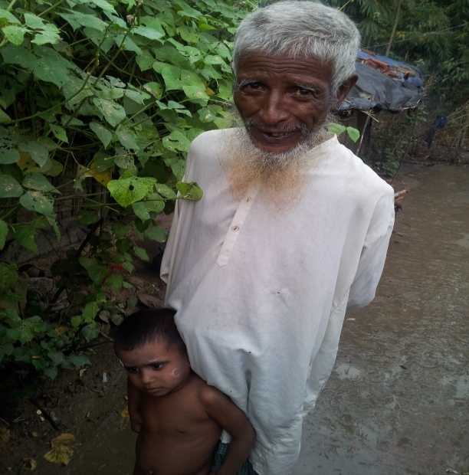

The only positive souls you could see in the camp were probably the children, and there were lots of them. Many of them followed me wherever I went and wanted me to take pictures of them. While some of them were really shy, others were braver and even tried to bully me. When I looked at all those innocent faces, I knew how their future would be if the international community do not step up and stop being silent. That really saddened me. They were so beautiful and happy. The only way you could tell that they are poor was probably their clothes - or rather, the lack of clothes. Many were not wearing pants and underwear. Shoes and even slippers were absolutely not a common sight in the camp too.

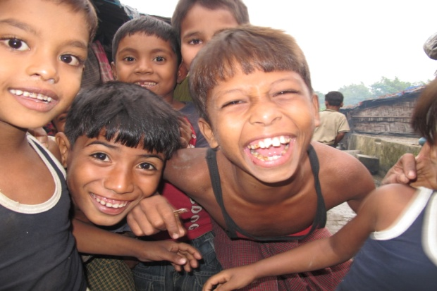 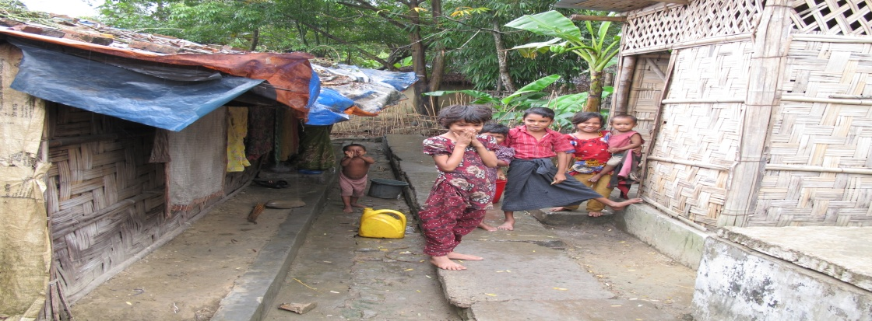

**A wishful thinking**

On the way back to my hotel we passed the river that divides Burma and Bangladesh. I was totally impressed by its beauty. Even the mountains on the horizon were looking stunning. If only the area was governed by honest and fair leaders, that region would have been one of the most beautiful areas in the world! Sadly though, today both Burma and Bangladesh are instead governed by some of the most corrupted regimes in the world leaving the civilians in suffering conditions – lacking in food, shelter and future.

Whatever the Burmese has done and still continues doing to the Rohingya is unquestionably evil, but what is even worse is the fact that the surrounding countries, who act as if they care in front of the Medias but in reality, treat the Rohingya really terrible. In Malaysia, the Rohingya are not recognized as refugees but illegal immigrants and therefore subject to arbitrary arrest, prison and all sorts of horrible abuses. The Arab countries, they are quick in condemning the Bengali authorities, but when it comes to helping the refugees by welcoming them to their countries they suddenly become silent.

The hypocrisy is just unspeakable. The ones who really suffer are the Rohingya children, the Rohingya mothers, the Rohingya fathers and of course the elderly who have suffered all their life. I don’t know how much more we can help as individuals, but I think we should not stop – until the day where the silent ones finally break their silence, and the oppressing ones cease their oppression.

May the younger generations of the Rohingya have a brighter future than the less fortunate current generation.